“I can do everything through Him who gives me strength.” -- Philippians 4:13
- Please show all your work! No partial credit will be given for incorrect answers with no work shown. Please draw a box around your final answer.
- Calculators are permitted, but no notes, text, laptops, PDAs, or electronic dictionaries. Cell phones should be muted and left in your pocket or bag.
- You are asked not to use the matrix or special financial functions of your calculator.
Total marks: 70

- Write an expression for the general term t_{n} of each sequence:
  - -2, -0.5, 1, 2.5, 4, 5.5, … [2]
t_{n} = -2 + 1.5(n-1) = -3.5 + 1.5n
  - -18, 6, -2, 2/3, -2/9, … [2]
t_{n} = -18(-1/3)^{n-1} = 54(-1/3)^{n}
  - ½, 2, 9/2, 8, 25/2, 18, 49/2, … [2]
t_{n} = n²/2
- Consider the series 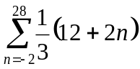.
  - What is the first term of the series? [1]
8/3 ≈ 2.67
  - What is the last term of the series? [2]
68/3 ≈ 22.67
  - What is the sum of the series? [3]
(8/3 + 68/3)(31/2) ≈ 392.67
- Consider the series 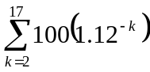.
  - What is the first term of the series? [1]
100(1.12⁻²) ≈ 79.7
  - What is the last term of the series? [2]
100(1.07⁻¹⁷) ≈ 14.56
  - What is the sum of the series? [3]
≈ 622.68
- Write the 3x3 matrix whose entries are given by a_{ij} = i (-1) ^{j} [3]
-1 1 -1
-2 2 -2
-3 3 -3
- Transpose the matrix from the previous problem. [2]
-1 -2 -3
1 2 3
-1 -2 -3
- Multiply: 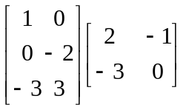 [3]
2 -1
6 0
-15 3

- Invert the matrix: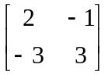 [4]
1 1/3
1 2/3
- A simple economy consists of (M)anufacturing and (T)ransportation. To produce one unit of M requires ½ unit of M and no T. To produce one unit of T requires 1/3 unit of M and 1/3 unit of T. What production levels of M and T are required to meet an external demand of 80 units of M and 100 units of T? [6]
A:
1/2 1/3
0 1/3
(I-A)⁻¹:
2 1
0 3/2
260 units Manufacturing
150 units Transportation
- A ball is released at a height of 640 cm and bounces off the floor below. Each bounce is 3/4 of the height of the previous bounce?
  - How high is the 4th bounce? [2]
202.5
  - How far does the ball travel (up and down) before it stops? [4]
640 + 2(1920) = 4480
- Elma took out a mortgage for $350,000 to buy a house. She repaid this by fixed amounts at the end of each month for 20 years. The interest rate is 5.9% p.a. compounded monthly.
  - What are her monthly payments? [6]
$2487.36
  - What is the finance charge of the loan? [2]
$246,966.15
- You listen to your mom and save $40 at the start of each month in a bank account that earns 9% compounded monthly. What is the balance after 20 years? [6]

$26,915.84
- What is the doubling time of an investment that earns 9% a year, compounded continuously? That is, how long will it take for an initial investment to double in value? [3]
~ 7.70 yr
- A company produces two models of automobile cold-air intakes, model A and model B. To produce each model A requires 3 lb of aluminum and 6 min of labour. To produce each model B requires 4 lb of aluminum and 3 min of labour. A total of 1000 lb of aluminum and 20 labour-hours are available for the production of cold-air intakes each day.
  - Sketch a graph, shading the region representing the allowable number of models A and B the company can produce each day. [8]
.
3A + 4B ≤ 1000
6A + 3B ≤ 1200
corners: (0, 0), (0, 250), (200, 0), (120, 160)
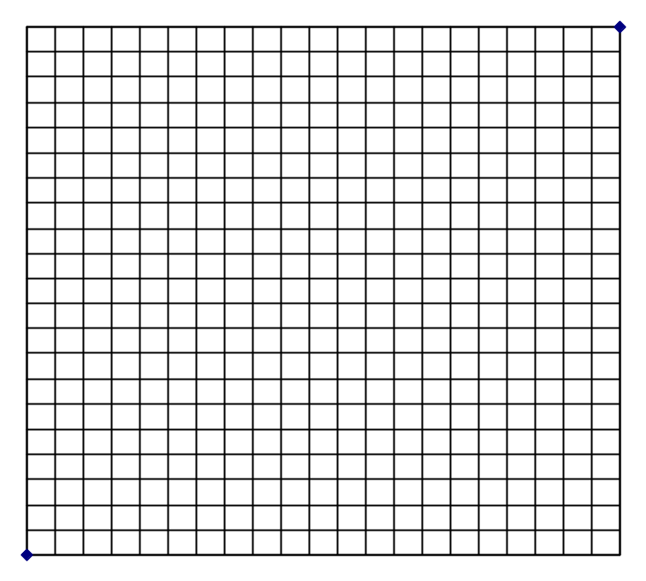
  - The profit for each model A intake is $2.00, and the profit for each model B intake is $1.70. How many intakes of each model should the company produce each day in order to maximize profit? [3]
$512 @(120,160)

